0%
Gap Analysis
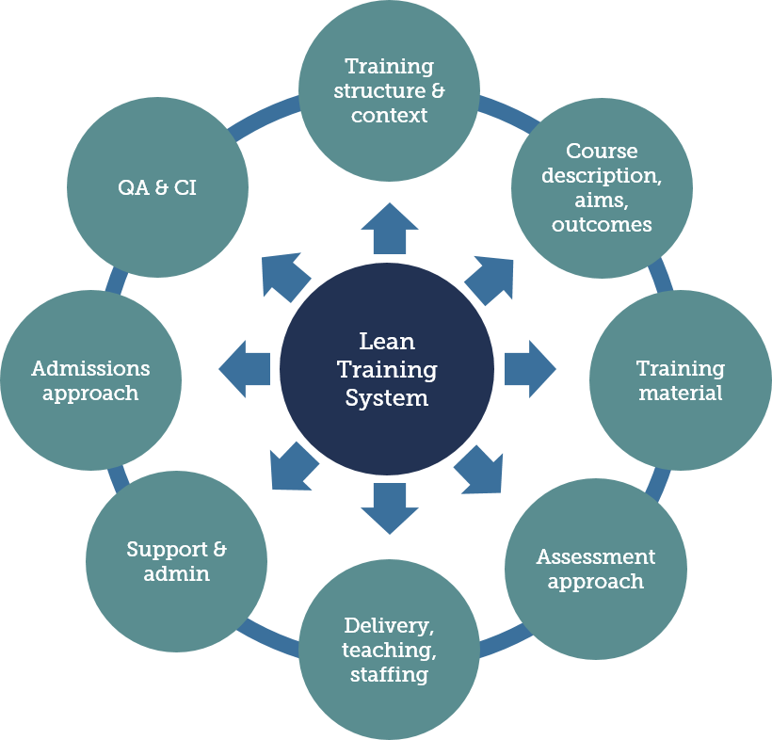
A Gap Analysis is used to identify the gap between the applicant’s current lean training system and one that meets the LCS accreditation standard.
A review of each key component of the current system is undertaken and the specific gaps are identified.
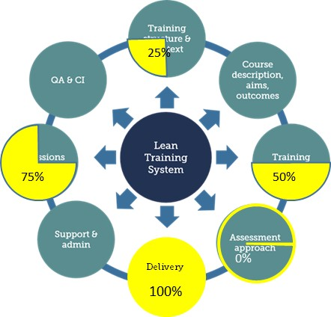
An estimate can be made of the degree to which it already meets the expected standard – for example, 0%, 25%, 50%, 75% or 100%.
The work required to bridge the gap is then specified, including the specific deliverables, resources required, responsibility and target completion date.
The table below can be used to plan and monitor progress (or adjusted according to personal preference).

Training System Component | Details | % already in place | Specific Gaps | Work Required to Bridge Gap | Responsibility | Target Completion Date
Background & Context | Organisation Background Information | Choose an item. |  |  |  | Click here to enter a date.
 | Organisation’s use of the LCS | Choose an item. |  |  |  | Click here to enter a date.
 | Certificates Issued pa | Choose an item. |  |  |  | Click here to enter a date.
 | Lean Training System Structure & Components | Choose an item. |  |  |  | Click here to enter a date.
 | LCS levels to which training system aligned | Choose an item. |  |  |  | Click here to enter a date.
 | Alignment matrix | Choose an item. |  |  |  | Click here to enter a date.
Course descriptions, aims, learning outcomes | Course titles & topics covered | Choose an item. |  |  |  | Click here to enter a date.
 | Topics Covered | Choose an item. |  |  |  | Click here to enter a date.
 | Aims & learning outcomes | Choose an item. |  |  |  | Click here to enter a date.
 | Learning Time | Choose an item. |  |  |  | Click here to enter a date.
Training Material | Presentations, workbooks etc | Choose an item. |  |  |  | Click here to enter a date.
 | Practical activities | Choose an item. |  |  |  | Click here to enter a date.
Assessment | Assessment approach | Choose an item. |  |  |  | Click here to enter a date.
 | Tests, exams etc | Choose an item. |  |  |  | Click here to enter a date.
 | Assessment administration | Choose an item. |  |  |  | Click here to enter a date.
 | Implementation evidence linkage, approach and mechanisms | Choose an item. |  |  |  | Click here to enter a date.
Delivery, Teaching Methods & Staffing | Teaching methods | Choose an item. |  |  |  | Click here to enter a date.
 | Capability assessment | Choose an item. |  |  |  | Click here to enter a date.
 | Deliverers biographies | Choose an item. |  |  |  | Click here to enter a date.
 | Delivery style approach | Choose an item. |  |  |  | Click here to enter a date.
QA, CI processes | Methods to select course participants | Choose an item. |  |  |  | Click here to enter a date.
 | Training evaluation approach | Choose an item. |  |  |  | Click here to enter a date.
 | Learner evaluation questionnaires | Choose an item. |  |  |  | Click here to enter a date.
 | Other learner feedback & review mechanisms | Choose an item. |  |  |  | Click here to enter a date.
 | Course review & CI processes | Choose an item. |  |  |  | Click here to enter a date.
 | International Coordination & Management | Choose an item. |  |  |  | Click here to enter a date.
Training Support & Organisation | Training facilities | Choose an item. |  |  |  | Click here to enter a date.
 | Training programme management & support | Choose an item. |  |  |  | Click here to enter a date.
 | Training records system | Choose an item. |  |  |  | Click here to enter a date.
 | Learner resources | Choose an item. |  |  |  | Click here to enter a date.

